Programming Written Assignment

***Mini Library Management System***

by Cheng Sheh Nee AA2301

IT1303

**Table of Contents**

Page

**Overview** **2**

**Assumption 2**

1. **Main Functions 3**
   1. Function 1 – Add New Book 4
   2. Function 2 – Update Existing Book 5
   3. Function 3 – Remove Existing Book 7

1.4. Function 4 – View Books 8

1. **Additional Functions 9**
   1. Function 5 – Search Book 9
   2. Function 6 – Borrow Book 10
   3. Function 7 – Return Book 12

* 1. Function 8 – Summary of Borrowed Book 13

2.5. Function 9 – Fine Management 13

2.6. Function 10 – Exit 14

**References** **14**

**Overview**

The Mini Library Management System is an application designed to store book information and manage the operations of a library. The application consists of 4 main functions – *Add New Book, Update Existing Book, Remove Existing Book* and *View Books*. In addition, the application offers other useful functions. The main goal of the application is to make the library’s collection and services more organised, efficient and accessible.

A list of book information will be stored in the library:

The book information includes *ISBN number, book title, book type* and *quantity available*.

ISBN is a unique identifier that is assigned to every published book or book-liked product.

Only 3 types of books are allowed to store in the library: *Hard Cover, Paper Back and eBook*.

The list of books and their relevant information that is stored in the library:

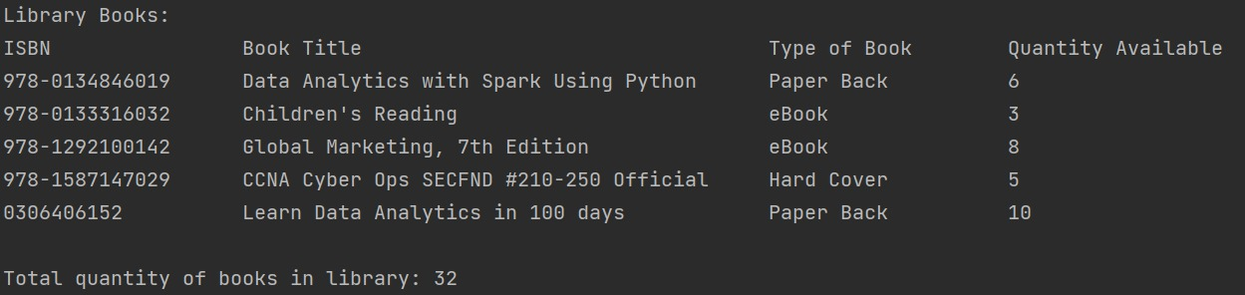

**Assumption**

* this program is only for librarians to access (hence username and password are required)
* the calculation of overdue days will start 30 days after the day of borrowing
* an overdue fine of $0.50 per day will accumulate as the number of overdue days increases

**1. Main Functions**

There will be four main functions that align with the CRUD principles: Create, Read, Update and Delete.

Additionally, a user login function within the application has been incorporated to enhance security and offer personalized access.

In this case, the valid username will be *Administrator* and the password is *Pa$$w0rd*.

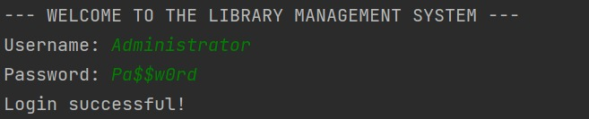

Please note that the username and password are case-sensitive. An error message will be displayed if an invalid username or incorrect password has been entered.

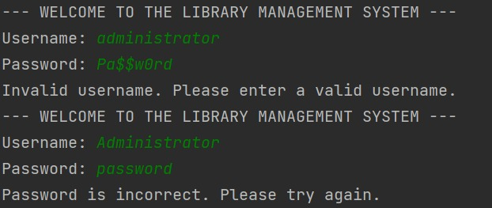

The main menu will be displayed once the user has successfully logged in.

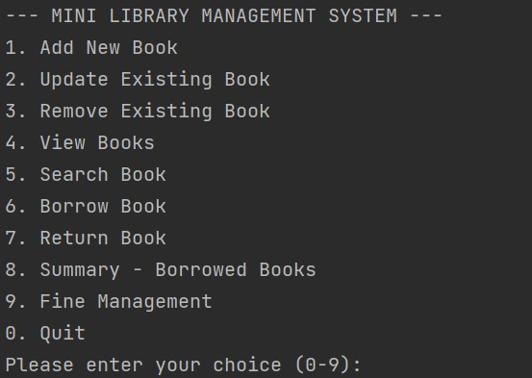

* 1. **Function 1 – Add New Book**

This function allows users to add a new book and store its information in the library.

To proceed, a valid ISBN number must be provided. An error message (“Invalid ISBN. Please enter a valid ISBN.”) will be prompted if the user has entered an invalid ISBN number. Additional details such as the book title, type and quantity available are also necessary.

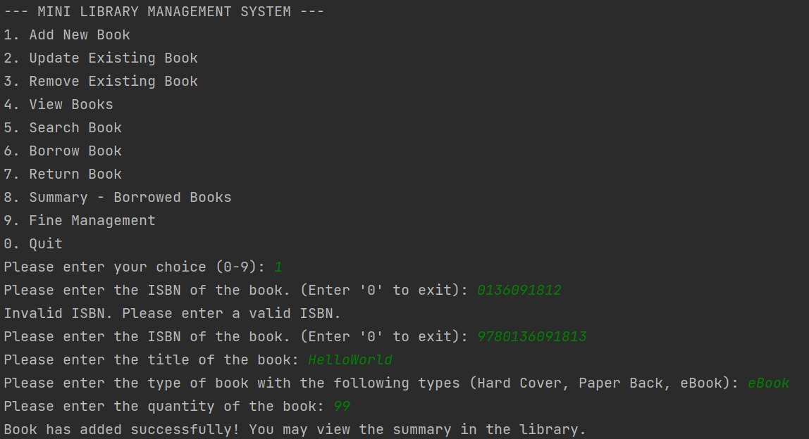

Users can review the book that has been added using function 4 – View Books.

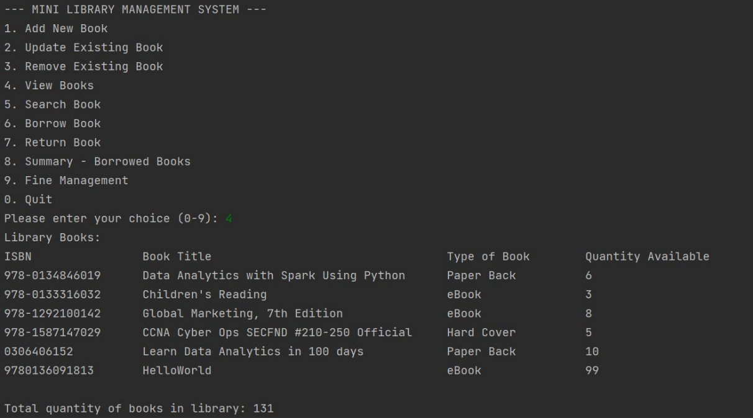

If the user enters a valid ISBN number that is already stored in the library, they will receive an error message and instruction suggesting the user update the information of the existing book instead (function 2).

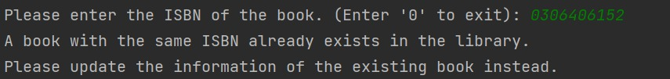

The user’s input for book type and quantity will also be validated.

A relevant error message will be displayed along with the instructions if there are any issues.

Validation of types of book (case sensitive):



Validation of quantity of book:

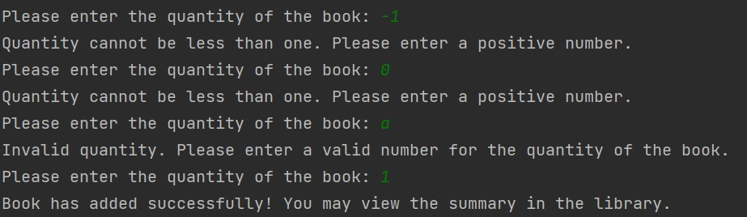

**1.2 Function 2 – Update Existing Book**

This function allows the user to update the information of the existing book that has been stored in the library. Please note that the ISBN number, which serves as a unique identifier (distinguishes one addition from another), cannot be changed. Only the book title, type and quantity available can be updated.

To proceed, a valid ISBN number that is stored in the library must be provided. An error message (“Book with the given ISBN not found in the library. Please try again”) will be displayed if the user has entered an ISBN number that is not stored in the library.

When a valid ISBN number that is stored in the library is entered by the user (indicating the book can be found in the library), the corresponding book information will be shown. Options to update the book title, type or quantity will be available for the user as well as an exit option for the user who wishes to exit the program.

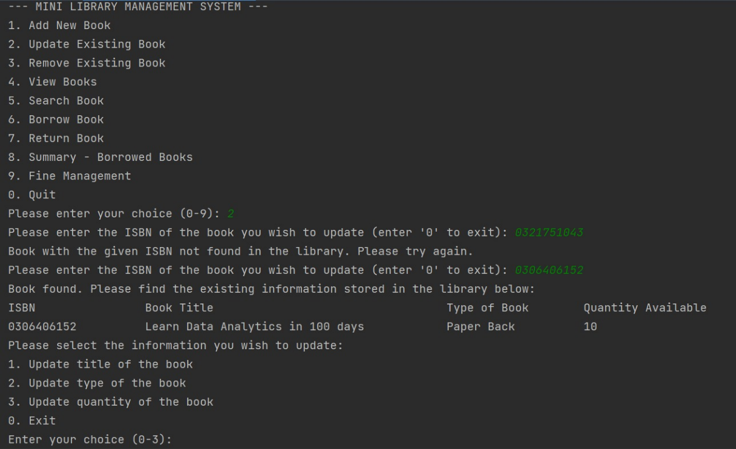

Update title of the book:

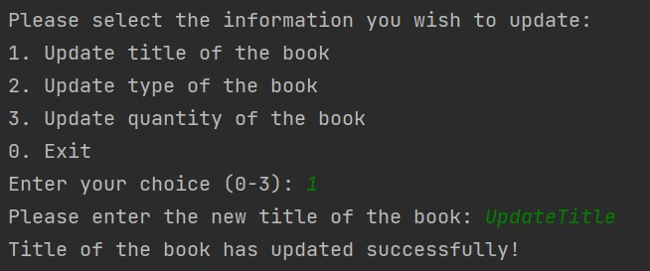

Update type of the book (with validation, case sensitive):

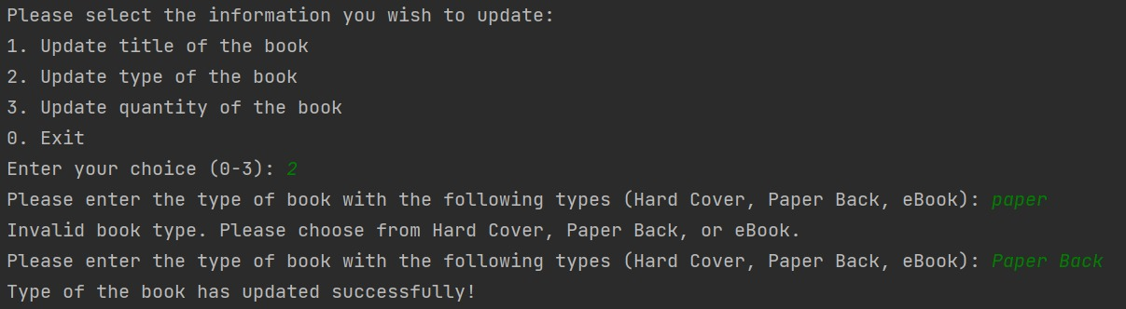

Update the quantity of the book (with validation):

*Zero is allowed for this case as it could reflect that all books are currently borrowed. The book information will still remain in the system.*

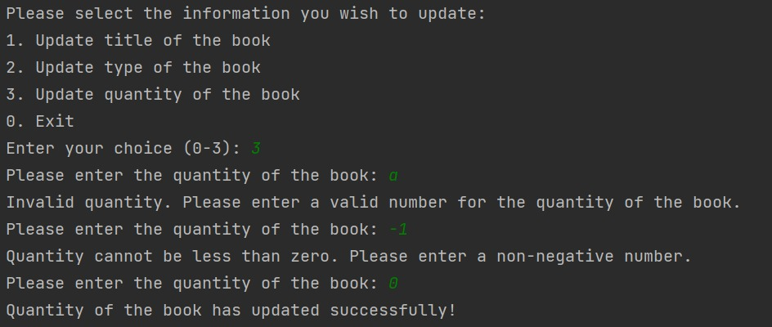

Users can review the book that has just been updated using function 4 – View Books.

**1.3 Function 3: Remove Existing Book**

This function allows users to remove existing book with its relevant information from the library.

To proceed, a valid ISBN number that is stored in the library must be provided. Upon confirmation, the ISBN number and book title will be displayed. Removal of the book will be successful if ‘yes’ is entered upon confirmation.

The book ‘Learn Data Analytics in 100 days’ with ISBN ‘0306406152’ has been removed from the library.

This can be reviewed using function 4 – View Books.

An error message (“Book with the given ISBN not found in the library. Please try again”) will be displayed if user has entered an ISBN number that is not stored in the library.



Validation for confirmation will be in the form of ‘yes’ or ‘no’.

Book removal will be cancelled if ‘no’ is entered.

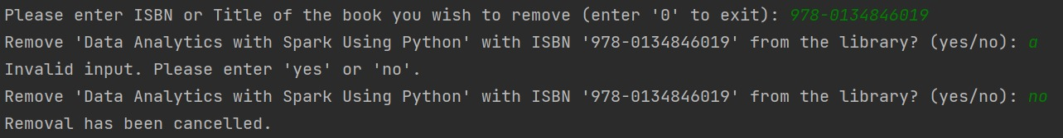

**1.4 Function 4 – View Books**

This function allows users to view books with their relevant information in the library.

**2. Additional Functions**

There will be several additional functions designed to further enhance the capabilities of the library management system.

**2.1 Function 5 – Search Book**

This function allows users to search book from the library using ISBN number, book title or keywords and book type. The relevant information will be displayed if the book is present in the library.

Search book by using ISBN:

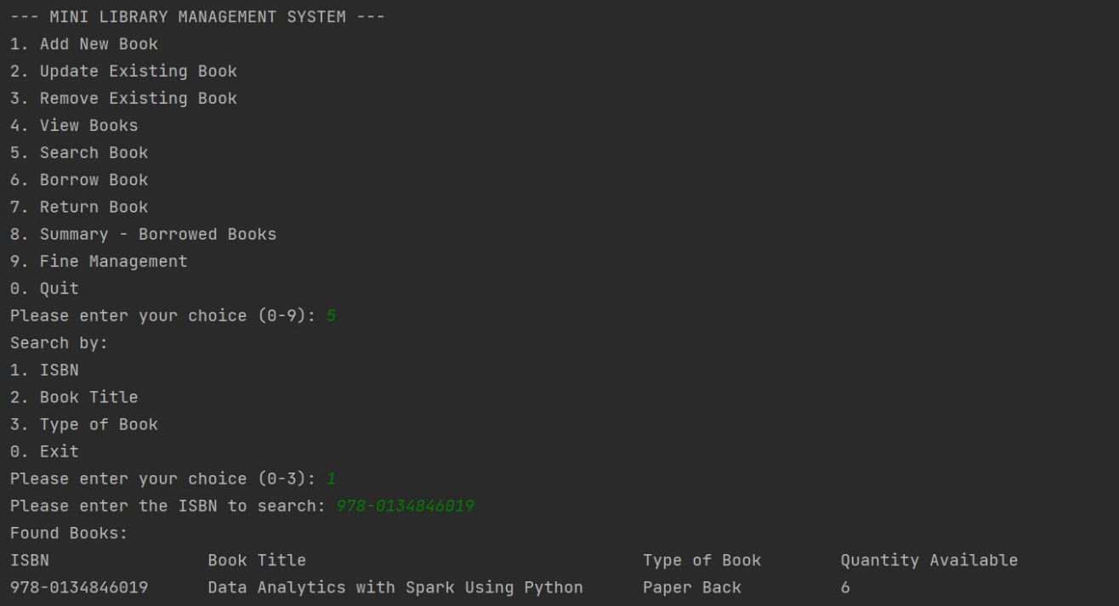

An error message will be displayed if a book with the provided ISBN number is not found.

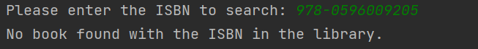

Search the book by using the title or keywords:

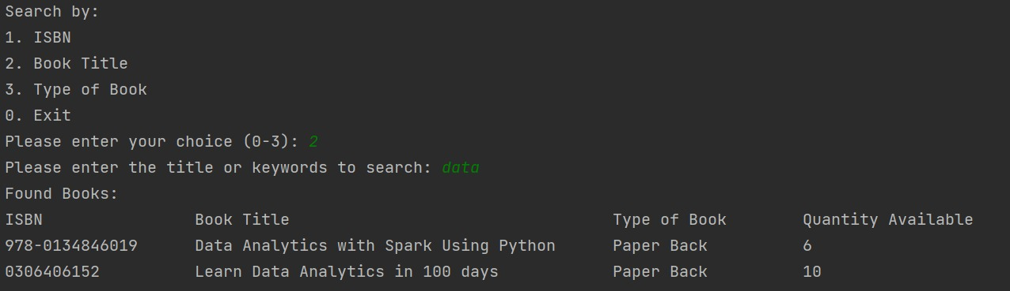

An error message will be displayed if a book with the provided title or keywords is not found.

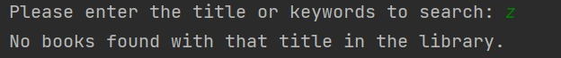

Search book by using the type of book:

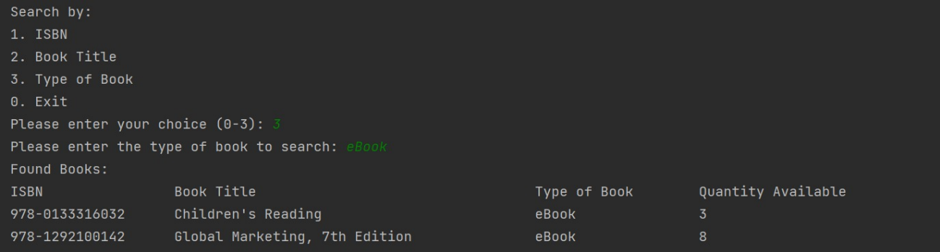

An error message will be displayed if a book with the provided book type is not found.



**2.2 Function 6 – Borrow Book**

This function allows users to borrow book from the library.

To proceed, the user will have the option to search the book using the ISBN number, book title or keywords. Book information will be displayed if it is present in the library. Both the ISBN number and the desired quantity for borrowing are necessary.

Search book by using ISBN and proceed to borrow a book:

*The quantity available in the library will be updated automatically by the system. A reminder of return book(s) within 30 days will be displayed.*

An error message will be displayed if a book is not found with the ISBN number provided.

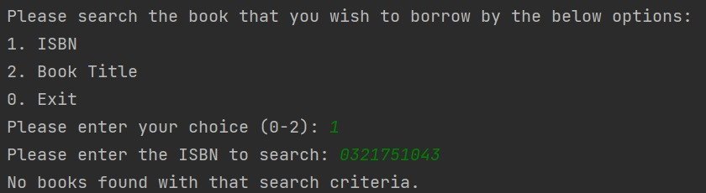

Search book by using the title or keywords and proceed to borrow a book (updated quantity available in the library will be displayed):

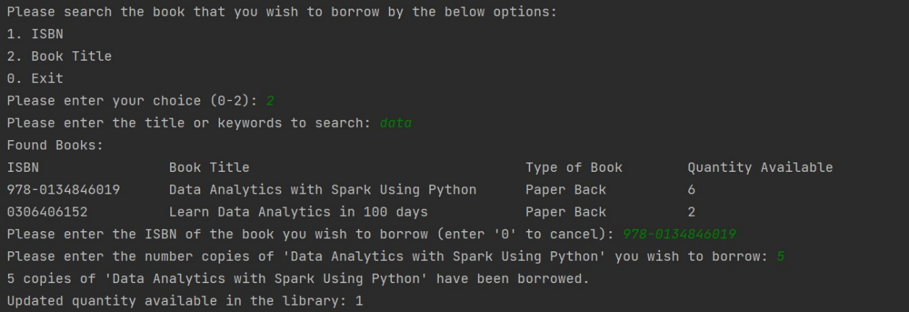

An error message will be displayed if a book is not found with the title or keywords provided.

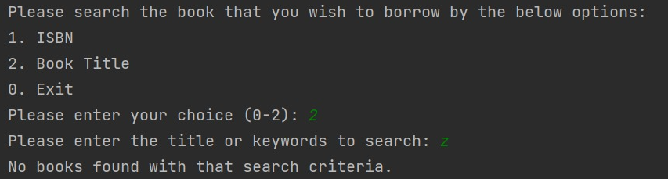

Validation of the quantity of books to borrow:

**2.3 Function 7 – Return Book**

This function allows the user to return the book(s) to the library.

To proceed, the user is required to enter the ISBN number (which can be found on the book itself since the user has the book with them). If the book is found in the library, a message will be prompted for the desired quantity for return (an updated quantity available in the library will be displayed).

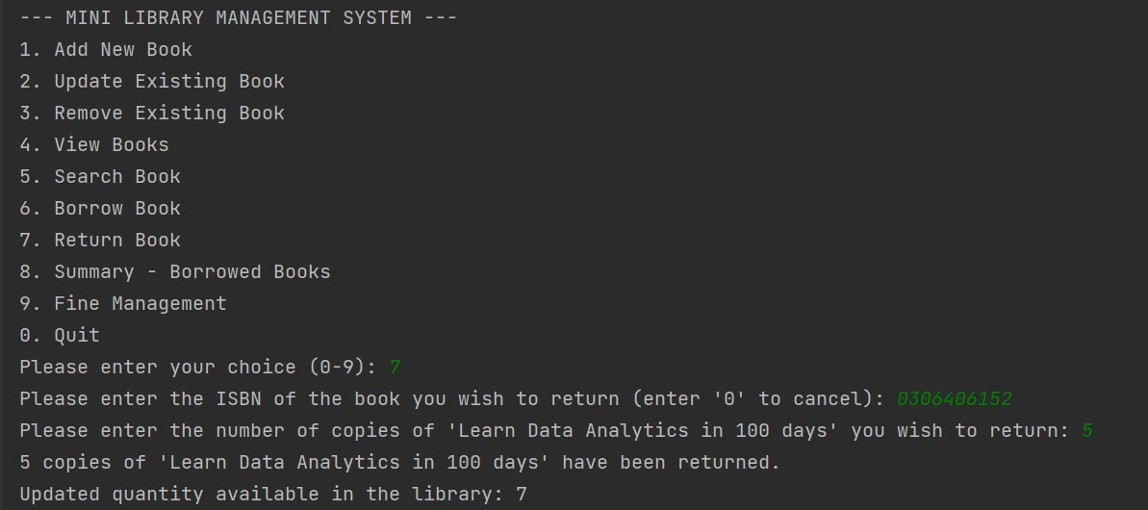

An error message will be displayed if a book is not found with the ISBN number provided.

*The book must be registered and stored in the library (Add New Book).*



Update quantity available in the library with the number of books returned (with validation):

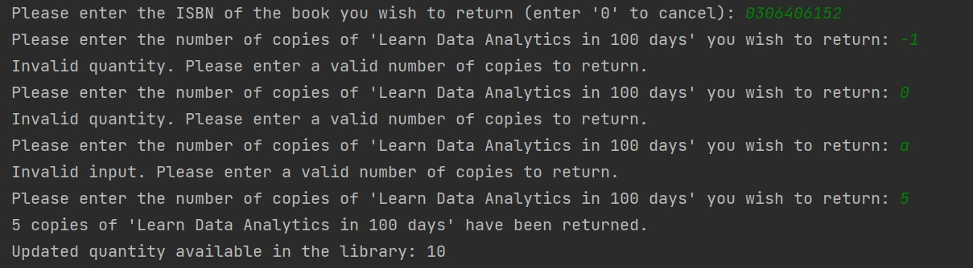

**2.4 Function 8 – Summary of Borrowed Book**

This function allows the user to generate a summary of borrowed books that are pending to be returned. This function is associated with function 6 – Borrow Book.

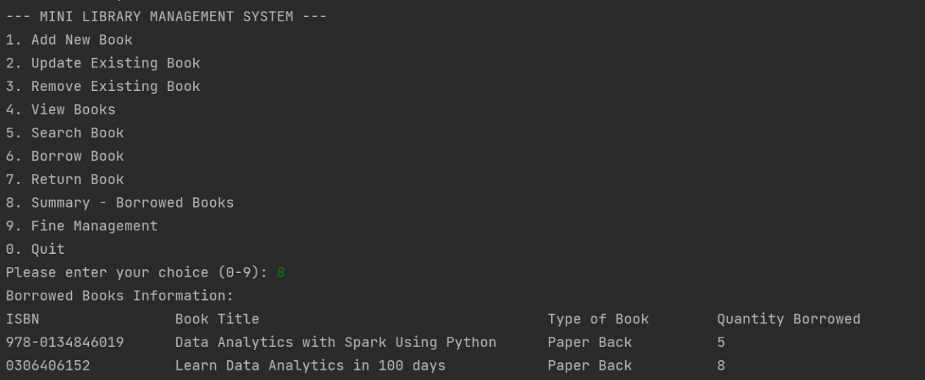

**2.5 Function 9 – Fine Management**

This function allows the user to calculate the fine for the books that have not been returned after the 30-day overdue period.

To proceed, the user is required to enter the ISBN number. If the book is found in the borrowed book summary, a message will be prompted for the date of borrowing. Subsequently, the system will display the overdue days and the corresponding fine amount.

No fine will be issued if the book is not overdue.

An error message will be displayed if a future date has been entered.

*Borrowing a book is not allowed for future dates.*

Validation of date format.

**2.6 Function 10 – Exit**

This function allows the user to exit the application.

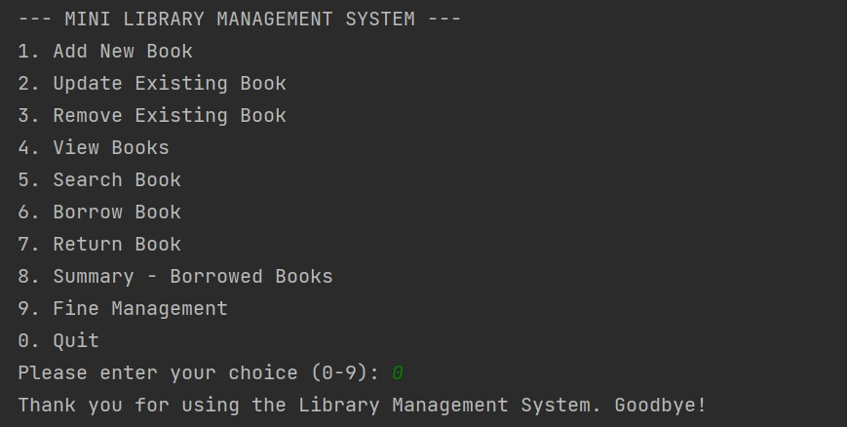

**Reference**

Valid and Invalid ISBN

<https://www.cis.upenn.edu/~cis110/11fa/hw/hw04/index.html>

How to verify ISBN

<https://www.instructables.com/How-to-verify-a-ISBN/>

For the ISBN validation function in my code, I got it online and simplify the code using ChatGPT so it is easier for me to study and understand the code. However, I could not find the link for the original code (before simplifying).